**INSPERITY CODE CHALLENGE – TEST EVIDENCE**

**Unit Test**

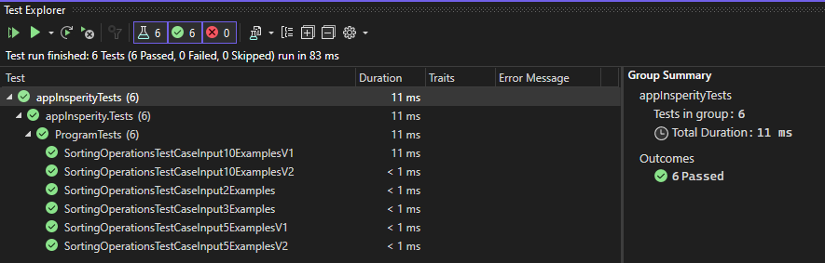

**Test Case 1 – N = 2**

|  |  |
| --- | --- |
| **Input** | **Expected Output** |
| abaccadcc  xyzxy | ccccaaabd  xxyyz |

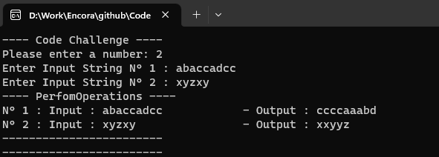

**Test Case 2 – N = 10**

|  |  |
| --- | --- |
| **Input** | **Expected Output** |
| dulgvgzwqg  gxtjtmtywr  hnlnxiupgt  gzjotckivp  dpwwsdptae  pcscpilknb  btvyhhmflf  artrtnqxcr  nrtcmcoadn  fkdsgnekft | gggdlquvwz  tttgjmrwxy  nnghilptux  cgijkoptvz  ddppwwaest  ccppbiklns  ffhhblmtvy  rrrttacnqx  ccnnadmort  ffkkdegnst |

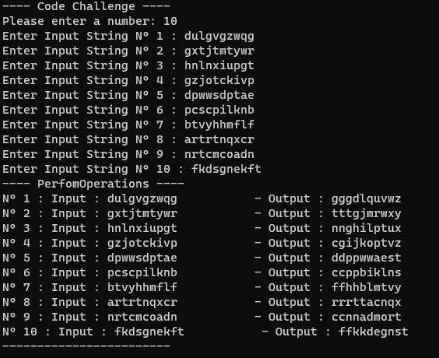

**Test Case 3 – N = 5**

|  |  |
| --- | --- |
| **Input** | **Expected Output** |
| wzenwebuau  vokfxzynwl  neldfeyrxk  wqadfiodgs  ykiuvzfcbc | eeuuwwabnz  fklnovwxyz  eedfklnrxy  ddafgioqsw  ccbfikuvyz |

**Test Case 4 – N = 10**

|  |  |
| --- | --- |
| **Input** | **Expected Output** |
| qakmc  rrtbk  vaixn  wmpnj  uproi  btska  ejqwr  elwlg  oaoiy  hrqkn | ackmq  rrbkt  ainvx  jmnpw  iopru  abkst  ejqrw  llegw  ooaiy  hknqr |

**Test Case 5 – N = 3**

|  |  |
| --- | --- |
| **Input** | **Expected Output** |
| pzjim  njnfq  xyohs | ijmpz  nnfjq  hosxy |

**Test Case 6 – N = 5**

|  |  |
| --- | --- |
| **Input** | **Expected Output** |
| xqycs  beoax  afkso  bldit  gwrys | cqsxy  abeox  afkos  bdilt  grswy |

